Functional Specification

Year: 2020

Semester: Spring

Team: 8

Project: AudioBeamer

Creation Date: January 22, 2020

Last Modified: January 24, 2020

Author: All of team 8

Email: [cheintze@purdue.edu](mailto:cheintze@purdue.edu), [athagart@purdue.edu](mailto:athagart@purdue.edu), [ctabachk@purdue.edu](mailto:ctabachk@purdue.edu), [abiala@purdue.edu](mailto:abiala@purdue.edu)

Assignment Evaluation:

|  |  |  |  |  |
| --- | --- | --- | --- | --- |
| **Item** | **Score (0-5)** | **Weight** | **Points** | **Notes** |
| **Assignment-Specific Items** | | | | |
| **Functional Description** |  | x3 |  |  |
| **Theory of Operation** |  | x3 |  |  |
| **Expected Usage Case** |  | x3 |  |  |
| **Design Constraints** |  | x3 |  |  |
| **Writing-Specific Items** | | | | |
| **Spelling and Grammar** |  | x2 |  |  |
| **Formatting and Citations** |  | x1 |  |  |
| **Figures and Graphs** |  | x2 |  |  |
| **Technical Writing Style** |  | x3 |  |  |
| **Total Score** |  | | |  |

5: Excellent 4: Good 3: Acceptable 2: Poor 1: Very Poor 0: Not attempted

General Comments:

*Relevant overall comments about the paper will be included here*

1.0 Functional Description

As a system, our device is responsible for transmitting and receiving an audio signal from an electric guitar while being able to control various audio equalization parameters such as bass, middle, treble as well as distortion with the purpose of eliminating the clutter of wires. All audio transmission is wireless, and the entire system is battery powered keeping with the wireless philosophy.

This device is divided into 2 physical units:

* The transmitter is responsible for modulating and wirelessly transmitting the audio signal from the electric guitar.
* The receiver is responsible for receiving the wireless signal, encoding the audio, applying digital signal processing, and communicating with an external Android phone app to control DSP parameters. The receiver will playback the audio from the transmitter through an audio codec through the MCU and finally outputted to an amp.

2.0 Theory of Operation

The operation of our device can be split into 3 main regions:

Audio Transmission: We plan to use a standard FM technique to transmit our audio wirelessly. Due to radio waves being at the speed of light, latency of transmission is not going to be an issue. This is a very robust system which handles external noise very well. Demodulation can remove noise sufficiently, mainly due to the modulation technique.

Frequency Modulation is a very robust technique that works by varying the difference between the carrier frequency and center frequency of a carrier signal. Demodulation is commonly accomplished using a Phase Locked Loop, but this is usually integrated in the ICs.

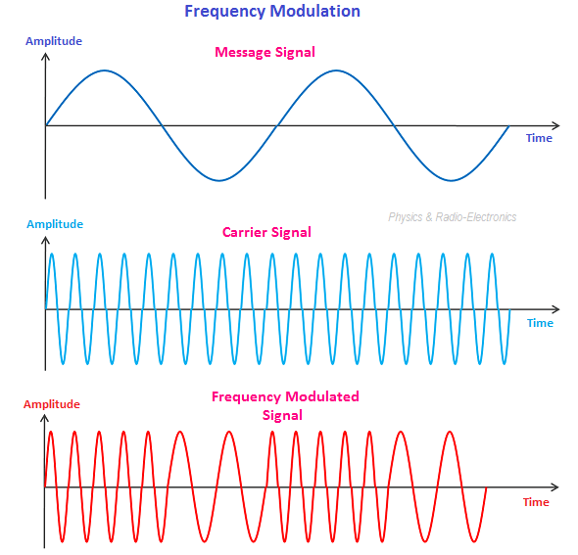

Audio Digital Signal Processing: This section is accomplished using DSP theory. The purpose of doing so that we perform digital mathematical operations that accomplish audio effects and equalization. The principal behind the operation of DSP is divided into 3 sections: ADC, processing, DAC. We need to use an ADC with a substantial resolution so that we can obtain discrete data from an analog audio signal. This discrete data is compiled into a wavetable where DSP operations converts the data into the frequency domain using FFT and performs operations that map to audio effects. This is then converted back to the time domain using IFFT. The discrete data is converted back to analog using a DAC.

Bluetooth communication: Bluetooth will be used as a means of sending user inputs to the device. Bluetooth low energy, specifically, would be used for communication between the device and the user’s phone. The phone will scan for the device’s signal, from which the phone and device will establish a Bluetooth connection. Once the connection is established, the phone can send small data messages to the device which will be used to change how the input signal is processed.

3.0 Expected Usage Case

This project is intended to be used indoors in a moderate/room temperature setting. The transmitter attached to the guitar is meant to be portable such that it does not impede the movement of the guitar player or of the guitar itself. The transmitter must therefore be somewhat vibration resistant. The receiver/processor is also meant to be used in a moderate/room temperature setting; however, it is not meant to be portable and it is not meant to be moved frequently. The users of our product can be in any age range so long as they are physically capable of playing guitar. They are expected to be technically literate enough to operate a phone application which controls the audio effects.

4.0 Design Constraints

* Using a battery will introduce constraints.
* Even though this is a prototype we intend to make it as compact as possible this might require us to design the PCB in an efficient way.

4.1 Computational Constraints

This project will need to do audio digital signal processing with low latency to minimize the lag between the user playing the guitar and the amplifier.

There are several computational constraints we identified. Firstly, the signal will be sampled at 44.1kHz using an audio codec which will then be transferred to the MCU. The microcontroller will be responsible for discrete FFT, convolution, fixed-point bit operations, and inverse FFT. These operations should be carried out by a capable DSP unit (32-bit fixed point) on the MCU to ensure real time performance.

Memory capacity is not something we think should be an issue. However, accessing the memory quickly is a priority and therefore suitable DMA will be required to store sampled wavetables and facilitate memory transfer in parallel with DSP calculations. A major constrain that we should consider is the timing of DSP calculations should be able to keep up with the Nyquist frequency to ensure no aliasing & good quality processing. The signal should be processed & manipulated in 16-bit audio quality.

4.2 Electronics Constraints

We are planning to use a limited number of peripherals:

1. Bluetooth receiver: The receiver will be able to communicate via Bluetooth the user’s Android phone application to change the parameters of audio effects & the digital signal processing. This Bluetooth receiver is expected to communicate with the MCU using UART.
2. Audio Codec: The chip will receive an audio signal from an electric guitar which will be encoded by the audio codec. The audio codec will communicate with the MCU via I2S and UART. UART will be used to transmit digitally sampled audio to the MCU & I2S will be used to send processed audio back to the Audio codec so that we can deliver a higher resolution analog audio output, when compared to using an inbuilt DAC on an MCU. It is likely a voltage buffer, or some impedance matching will be required to isolate this system from potential loudspeaker systems which can have varying impedance. This is done to protect the current sensitive parts of the circuit
3. LED UI to display battery information: A simple multi-color LED that shows battery status (fully charged, medium charged, low charge). Most multi-color LED’s use PWM to control the color of the LED. Appropriate resistors will be added based on whether the LED is a common anode or common cathode configuration.
4. Radio FM transmitter & receiver: This is used to wirelessly transmit an audio signal from the transmitter to the receiver. The output of this peripheral is a demodulated audio analog audio signal that will be fed to the audio codec to be sampled. While there is no direct connection to the MCU, it is likely impedance matching will be required between the antenna and the receiver chip to maximize signal power transfer.

4.3 Thermal/Power Constraints

The battery life for both the transmitter and receiver should be at least 2 hours to allow enough time to play guitar for a single session. We plan to use a lithium ion battery.

A major factor that makes the battery life of this project very variable is the computational power required by the DSP unit in the MCU. The power consumed by the MCU varies on the amount of effects being used.

We do not expect operating temperature of the system to reach significantly large amounts because we assume a guitar will be used in a comfortable environment (25°C ± 15°C). Heat generation of the circuit should not be a concern because we do not plan to supply or operate on voltages greater than 5V and therefore we will not be enough energy to create a significant source of heat relative to the size of the average room.

4.4 Mechanical Constraints

This project will likely need to be dust proof because there may long periods of no use. The transmitter attached to the guitar needs to be vibration resistant to prevent breakage during usage. None of the components needs to be waterproof, but if a cheap waterproof casing is found then it may be used for convenience’s sake.

Both the receiver and transmitter will have to be relatively physically small and light. The transmitter will not be physically worn by the user but will be attached to a guitar which a user may potentially move around with which means that the transmitter will have to be light enough to not add significant heaviness to the guitar. The transmitter must also therefore be somewhat resistant to vibration.

Also, the receiver must also be somewhat vibration resistant in the case where someone is playing music loud enough through their amp to cause vibrations.

We were planning to satisfy these mechanical constraints by using 3d CAD/printing to design the enclosures of the transmitter and receiver.

4.5 Economic Constraints

The main economic constraint we have is the $425 budget. The project is estimated to cost less than the budget. We will have to be judicious with choosing the components in our project to both fit our budget and serve the purpose. Microcontroller costs are estimated at around $20, external Bluetooth modules are estimate at around $10, external audio codecs are estimated at around $10, and wireless audio transmission device is estimated at around $12. This puts the total cost of the device around $52. There will be various smaller components (LEDs, resistors, etc.) with minimal costs associated with them. The overall project would therefore cost under $60. This price is within the scope of other similar products on the market while providing additional functionality.

4.6 Other Constraints

Another goal for this project would be that the product is aesthetically pleasing enough for users to be willing to place it in the room that they plan to use their guitar. The receiver device will not be moved frequently and as such can be larger in this first implementation of the project. Additionally, a goal of this project is for there to be no physical connection between the guitar and the receiver.

5.0 Sources Cited:

1. Z. Settel and C. Lipp, “Real-Time Musical Applications using FFT-based Resynthesis,” January 1994. [Online]. Available: <https://www.researchgate.net/publication/247343587_Real-time_musical_applications_using_the_FFT-based_resynthesis/> [Accessed January 23, 2020].
2. “A Beginner's Guide to Digital Signal Processing (DSP),” 2020. [Online]. Available: analog.com/en/design-center/landing-pages/001/beginners-guide-to-dsp.html [Accessed January 24, 2020].
3. “Microchip Technology.” [Online]. Available: <http://www.nextwarehouse.com/item/?2516394_g10e&gclid=EAIaIQobChMInZbntYqd5wIVZf7jBx1fcAZaEAkYASABEgLj6PD_BwE> [Accessed January 24, 2020].
4. “Adafruit Audio FX Mini Sound Board - WAV/OGG Trigger - 2MB Flash.” [Online]. Available: <https://www.adafruit.com/product/2342> [Accessed January 24, 2020].
5. Asif Shaik, “Frequency Modulation,” 2020. [Online]. Available: <https://www.physics-and-radio-electronics.com/blog/frequency-modulation/> [Accessed January 24, 2020].
6. "Bluetooth Low Energy Overview,” December 2019. [Online]. Available: <https://developer.android.com/guide/topics/connectivity/bluetooth-le> [Accessed January 24, 2020].